08 | Implemented New Feature
  - Part 4 — Functional implementation and UI demonstration evidence
PROJECT SafeStep | Deliverable 8 | 11 November 2026
TEAM Zhumabay Dias · Temirlan Satybaldy · Beknur Ualikhanuly · Sagidolla Beibars · Saparbek Bekzat
STATUS / SCOPE: EVIDENCE DOCUMENT ONLY. Submission of actual working frontend/backend source or live demo remains necessary; this document does not replace executable software.

1. Implemented change
CR-01 — Payment Prefix Search and Status Filtering was integrated into the existing contact-centre payment queue (not a static mockup). The search uses the beginning of the entire customer ID or payee field; case is ignored and surrounding query spaces are trimmed. The text filter is combined with All / Held / Sent / Released / Cancelled status filtering.

2. File-level implementation map
Source path | Purpose
frontend/src/widgets/payments-queue/model/filterPayments.ts | Pure prefix/status filtering helper.
frontend/src/widgets/payments-queue/ui/PaymentsQueue.tsx | Controlled search/status state, counts and empty-results view.
frontend/src/shared/i18n/dictionaries.ts | Russian and Kazakh labels, hints, messages.
frontend/src/app/styles/index.css | Responsive filter layout.
frontend/tests/filterPayments.test.mjs | 14 automated filtering tests.
frontend/package.json | npm test command.
README.md | Final prefix-search acceptance rules.

3. Filtering logic (semantic summary)
A record is returned only when (status = All OR payment.status equals selected status) AND (query empty OR customer_id starts with normalized query OR payee starts with normalized query). It retains record order and does not mutate input records.

4. User-supplied browser evidence
Screenshot | Visible state | Interpretation
22.10.02 | All statuses, empty query: 31 / 31 | Baseline queue visible.
22.11.33 | Search aig, All: 27 / 31 | Positive customer-prefix results.
22.11.46 | Search ge, All: 0 / 31 | Negative prefix example + empty state.
22.12.25 | Search KZ12, All: 20 / 31 | Positive payee-prefix results.
22.12.52 | Search aig + Cancelled: 8 / 31 | Combined text and status filtering.

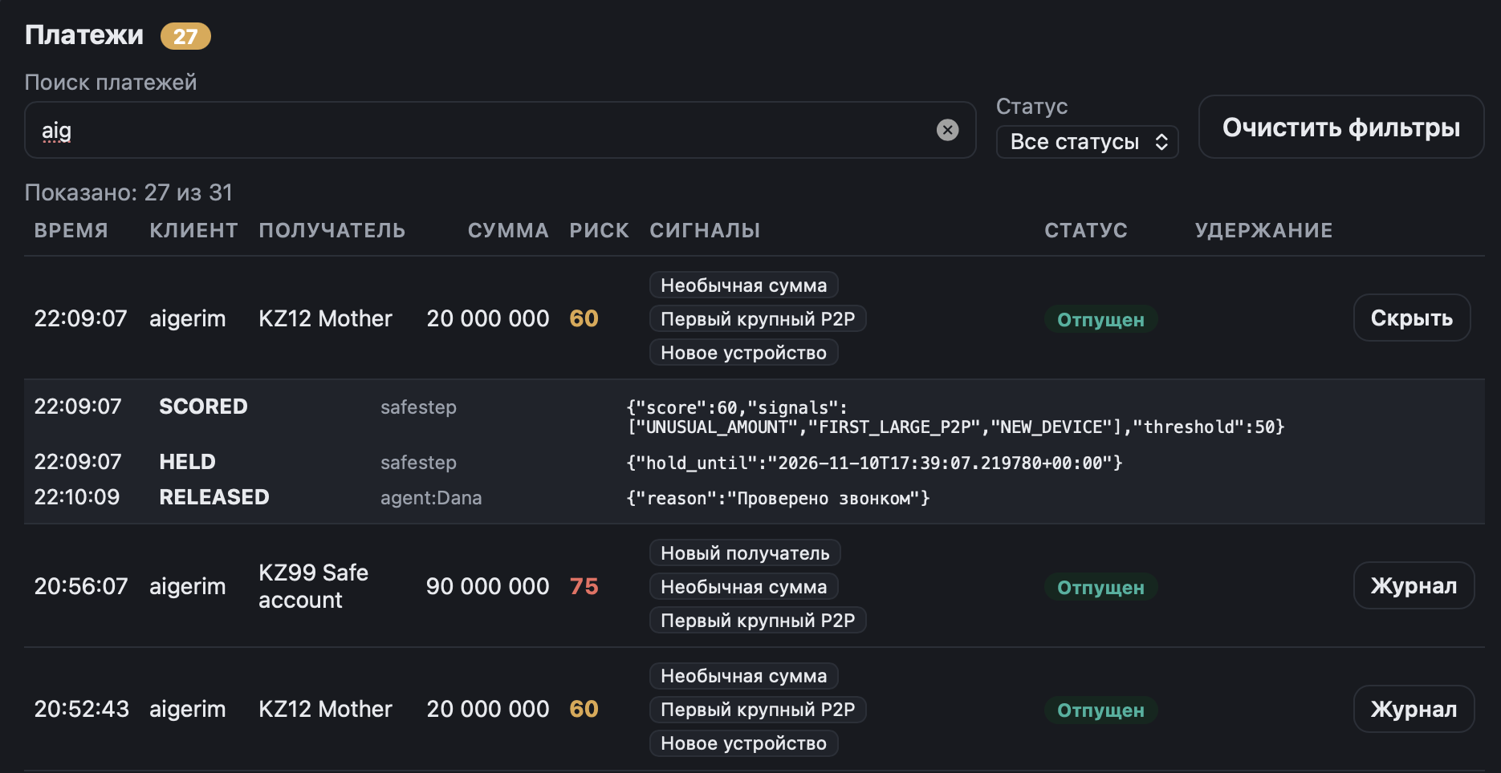
Figure 1. Search “aig” returns Aigerim records (27 of 31 loaded records).

Figure 2. Search “ge” returns no matches in this dataset; localized empty-state appears.
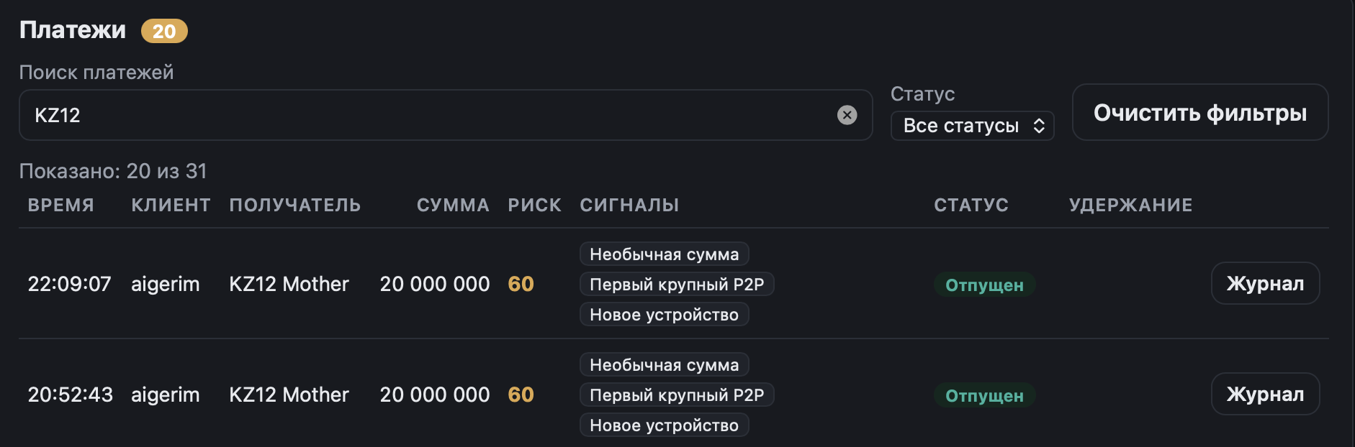
Figure 3. Search “KZ12” matches payees starting with KZ12 (20 of 31).
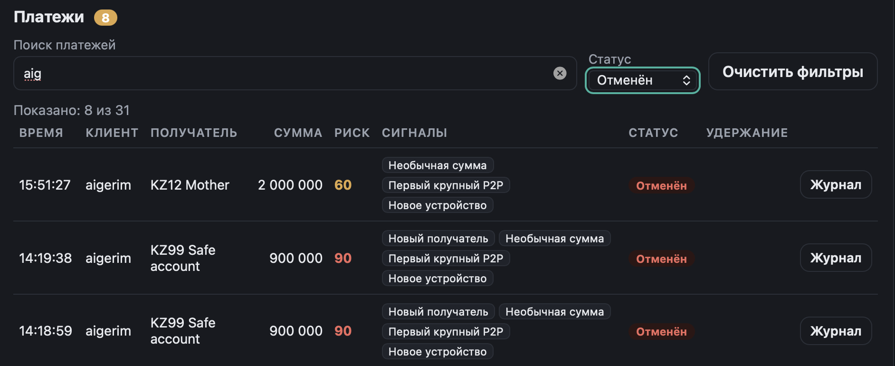
Figure 4. Search “aig” combined with Cancelled status (8 of 31).

5. Evidence limits
The screenshots demonstrate the key filtering cases. They do not directly show a Clear Filters click, both UI languages, negative inner-word “Mother” or each separate status selection. Those behaviours are specified and partly covered by the 14 logic tests, but are not all proven as rendered browser interactions. Counts describe one demo dataset and are not performance measurements.

6. Acceptance and availability
The project owner confirmed that the final prefix behaviour works after the initial substring search was corrected. The feature uses existing backend data; no new API or schema migration was added. For grading, include the actual application/repository and demonstrate the UI along with this evidence report.

